GPIO assignment
Technical Report

Author: Miroslav Denkov
Student number: 524298

Introduction

This report outlines the methods and execusion of the first assignment for the Semester3-ES class. The task is to understand bare-metal GPIO programming on the Nucleo F303RE microcontroller.

The requirements are the following:
- Connect two buttons and two LEDs
- When pressing the first button, it must toggle its corresponding LED.
- When the second button is pressed, the other LED lights up and turns off after a short period of time.
- The last task is to create something fun. In this case I chose, when both buttons are pressed, the second(green) LED to light up in a pattern, spelling “Hello!” in morse code.

Build design

The circuit used for this experiment is the following:

- Red LED connected to PA8
- Green LED connected to PA9
- PushButton Connected to PA6 (debounced with a 100nf capacitor)
- Additionally, the built-in button on the microcontroller is used as the other button, internally it is connected on PC13.
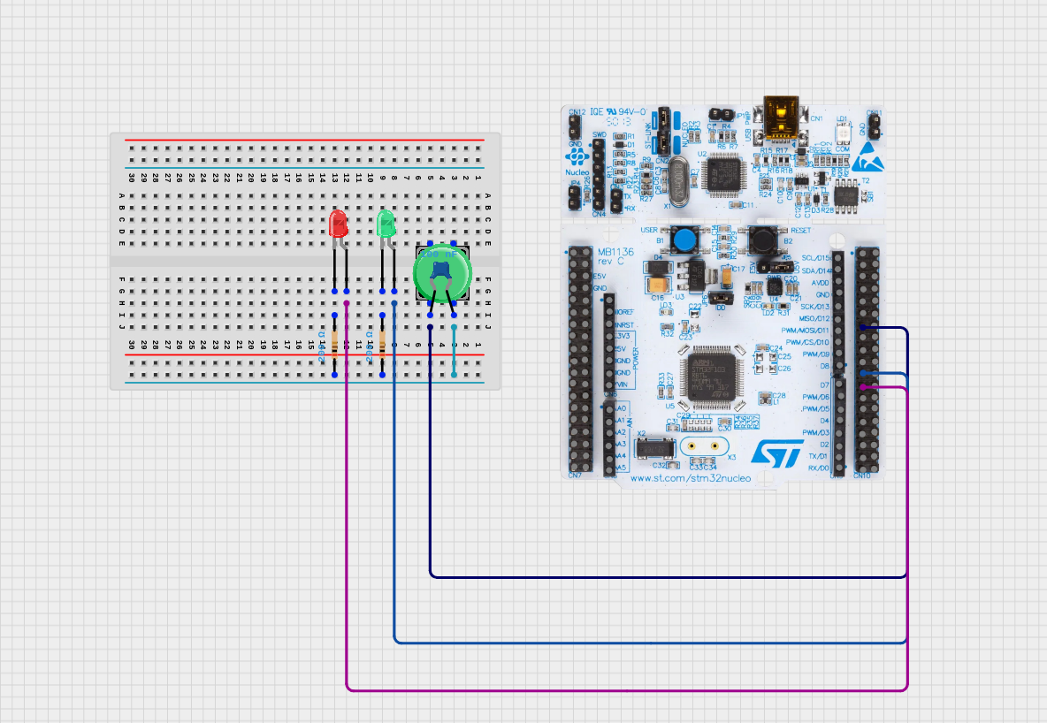

Evidence

- When the USER button is pressed the light on PA8 toggles
- When the button on PA6 is pressed the LED on PA9 turns on for 3 seconds and then turns off
- When both buttons are pressed the green LED starts spelling “Hello” in morse code.
Conclusion

For a first assignment, it was quite pleasant. I learned how to operate the GPIO on the Nucleo and also I learned a lot of embedded system concepts and how things work and why they must be set up(like the clock for example).

